CSA-1557 CLOUD COMPUTING LAB PRACTICAL

6.Create a simple cloud software application for Payroll Processing System using any Cloud Service Provider to demonstrate SaaS include the necessary fields such as Name of the employee, experience in present org , overall experience, basic pay, HRA, DA, TA, net pay, gross pay etc.

STEP-1:

Login into zoho.com and create an account.Then go to zoho creator and create a new application starting with a new form.Add or insert the required fields.

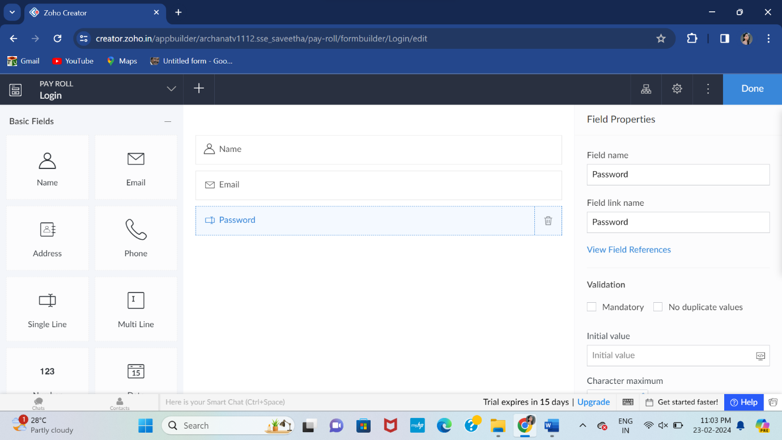

STEP-2:

Execute or run the model and get the required login form in live.

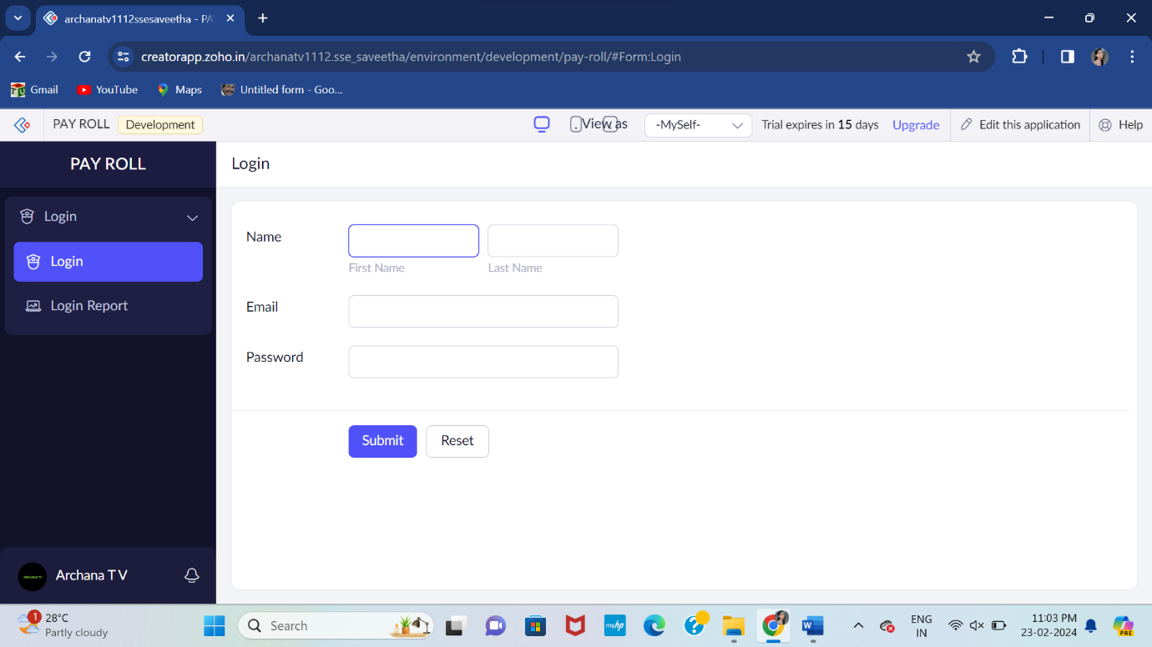

STEP-3:

Next step is to add another form which consists of employee details with the fields.

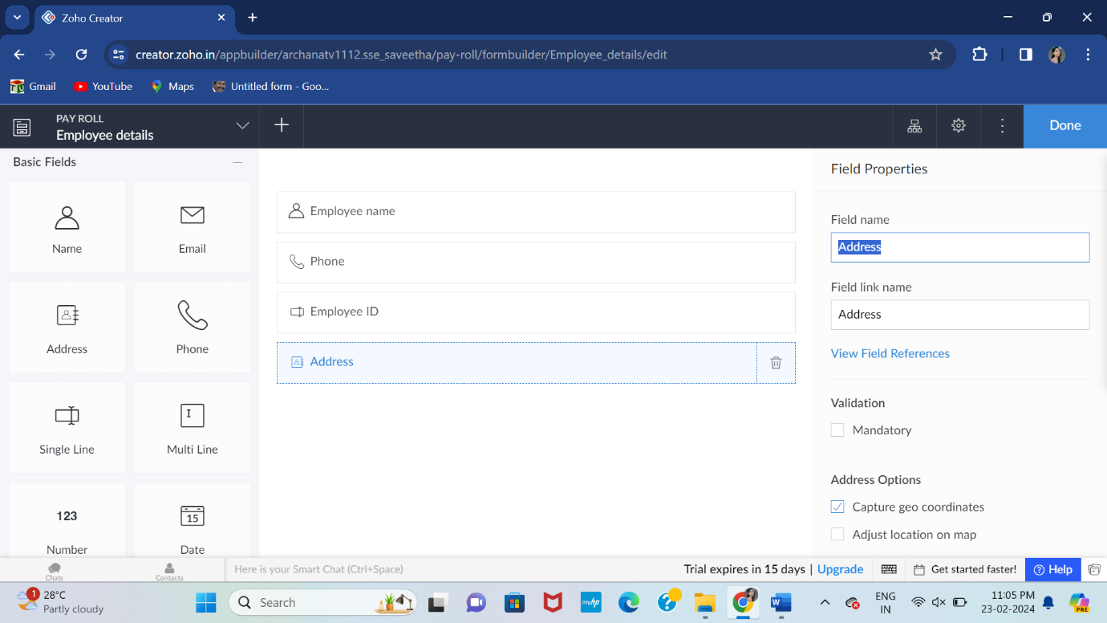

STEP-4:

Execute or run the model and get the required employee details from live.

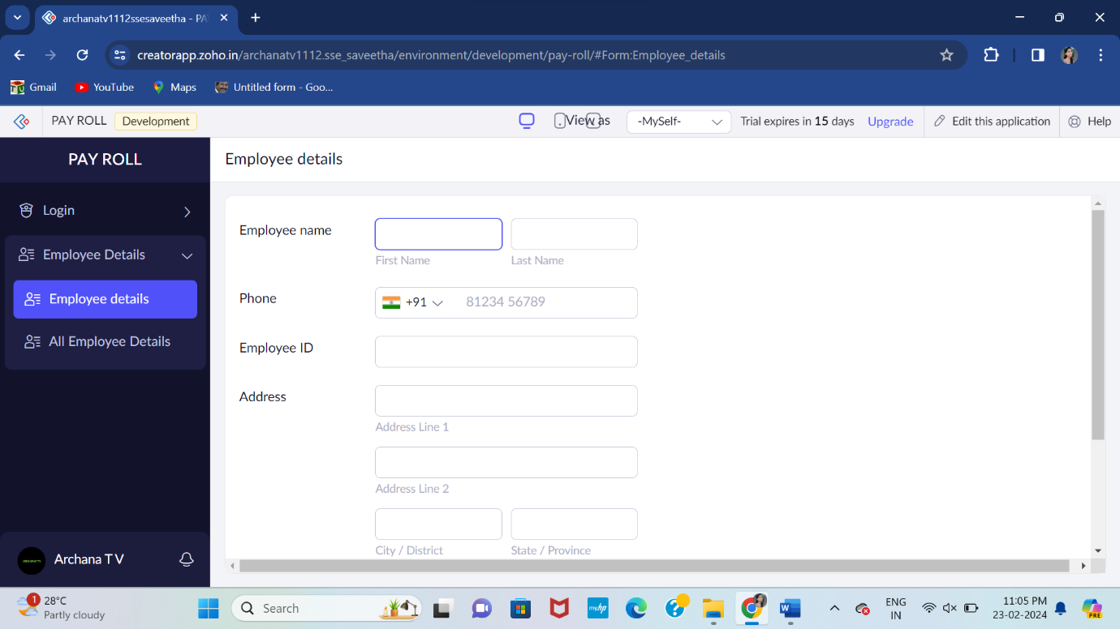

STEP-5:

Next step is to add another form which consists of employee salary details with the fields.

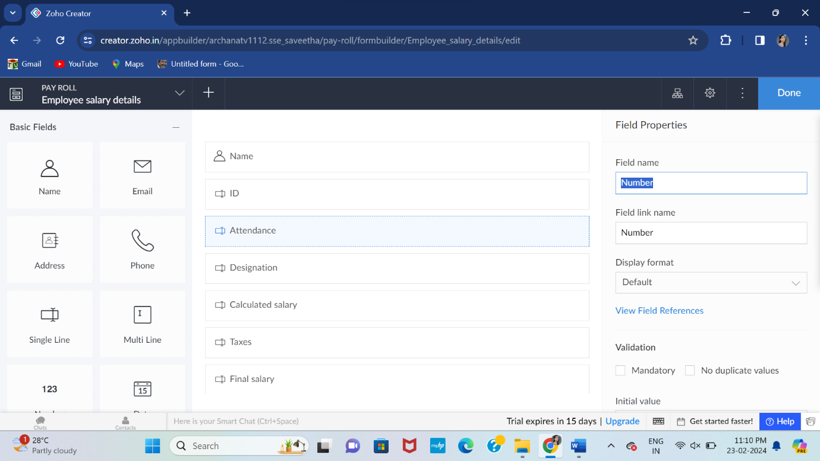

STEP-6:

Execute or run the model and get the required salary details from live.

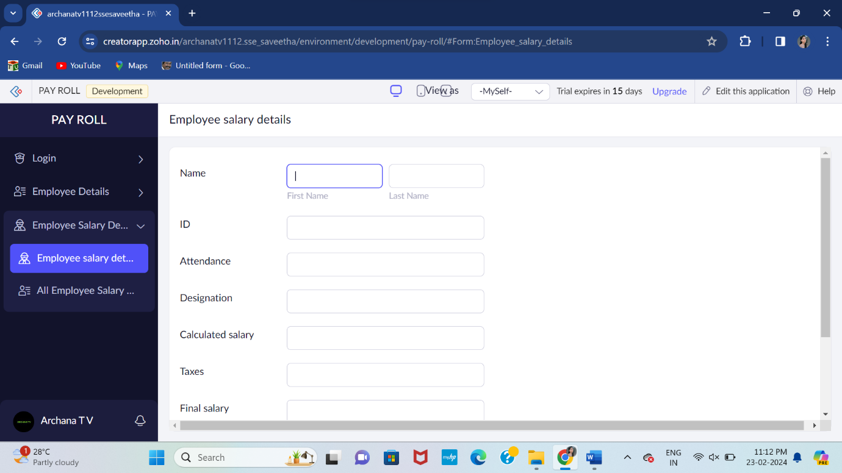

STEP-7:

Next step is to add another form which consists of logout details.

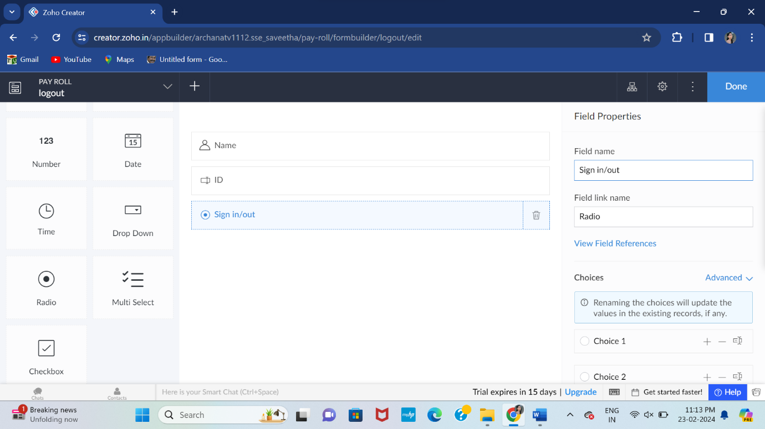

STEP-8:

The last step is to run and execute the contact details form and end the program.

